**CSSC Governor Development Session – ‘Supporting Schools to develop a trauma sensitive approach to practice.’ Recommended resource list.**

**1 - The Safeguarding Board NI** have a wealth of resources on trauma informed approaches and have recently published a comprehensive toolkit to support organisation and systems to embed a trauma informed approach. Click [here](https://www.safeguardingni.org/resources/trauma-informed-toolkit) to access the toolkit.

**](https://www.kazzum.org/free-resources/animating-adversity)2 - Kazzum Arts** are an organization who work with young people who have experienced high levels of Adverse Childhood Experiences. Their programmes use creative activities as a means of building confidence, communication skills, creativity and engagement in learning, whilst also helping children and young people to develop healthy relationships with others and the world around them. The animations shown during CSSC’s development session were provided by Kazzum Arts.

Click [here](https://www.kazzum.org/free-resources/animating-adversity) to access their site.

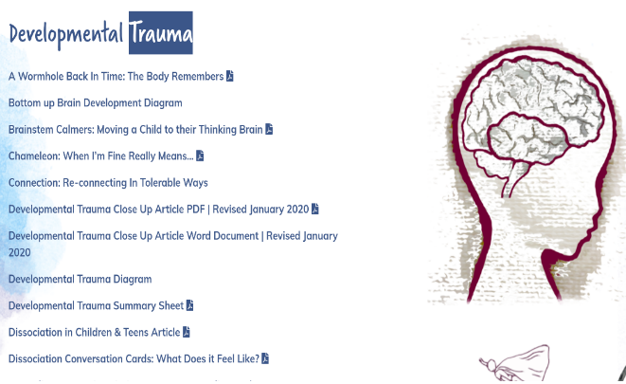**3 - Beacon House** are a team of psychologists, psychotherapists and occupational therapists who specialise in repairing the effects of trauma and attachment disruption.

For a wealth of written, visual and video resources on childhood trauma and supporting children’s regulation please click [here](https://beaconhouse.org.uk/resources/)

Beacon House also has resources available to support adults in regulating their emotions.

**4 - The Anna Freud National Centre for Children and Families** is an organisation which carries out clinical research into mental illness and delivers training which promotes a whole school approach to mental health and wellbeing. The Centre has developed a **Mentally Healthy Schools** site which includes freely downloadable resources which include lesson plans and further reading for staff Click [here](https://mentallyhealthyschools.org.uk/resources/) to explore the site. Click [here](https://www.annafreud.org/resources/schools-and-colleges/supporting-staff-wellbeing-in-schools/) for their specific content on staff wellbeing: -



[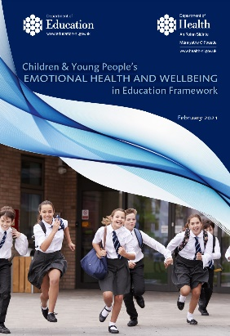](https://www.education-ni.gov.uk/sites/default/files/publications/education/Children%20%26%20Young%20People%20s%20Emotional%20Health%20and%20Wellbeing%20in%20Education%20Framework%20%28final%20version%29.PDF)

**5 - The Department of Education and Health** have developed the Children and Young People’s Emotional Health and Wellbeing in Education Framework in collaboration withrelevant statutory bodies and agencies, parents, carers, voluntary and community sector organisations and most importantly the children and young people themselves. The framework recognises our collective responsibility in supporting the emotional health and wellbeing of our children and young people and those working with them. The framework can be accessed [here](https://www.education-ni.gov.uk/sites/default/files/publications/education/Children%20%26%20Young%20People%20s%20Emotional%20Health%20and%20Wellbeing%20in%20Education%20Framework%20%28final%20version%29.PDF).

**6 - The Department of Education** have developed a self-assessment audit tool which includes information and questionnaires to support school development planning in the area of emotional health and wellbeing. The questionnaires relation to staff emotional health and wellbeing in CSSC’s governor development session can be found [here.](https://www.education-ni.gov.uk/publications/self-assessment-audit-tool-information-and-questionaires)

**7 - The Department of Education** have also developed a specific resource in relation to working with whole school communities to understand, nurture and support social behaviour and emotional wellbeing**. Click** [**here**](https://www.education-ni.gov.uk/sites/default/files/publications/education/SEN%20RESOURCE%20FILE-SBEW_0.pdf) **to access this resource.**

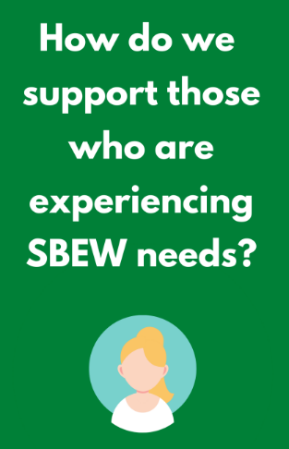

](file:///T:\Managing%20External%20Interactions\Ethos%20and%20Values\TIP%20resources\Take%205%20Leaflet%2001%2020.pdf)**8- The Public Health Agency** have developed a site which includes a variety of online resources to support adult health and wellbeing which include Steps to Deal with Stress and the Take 5 advice for wellbeing. Click [here](https://www.mindingyourhead.info/) to access these resources.

**9 - The EA Healthwell Hub** is a site which has a number of interactive resources which support EA’s Health and Wellbeing Strategy 2019-2022 for staff. It can be accessed on your computer, laptop or phone. Click [here](https://healthwell.eani.org.uk/) to view the content available.

**10 – Trauma Informed Schools UK** have a free 25-minute webinar which explains the benefits of supervision for staff wellbeing. To access click [here.](https://www.traumainformedschools.co.uk/online-supervision/free-supervision-webinar)

