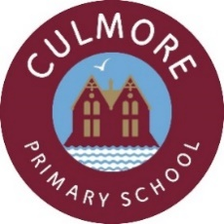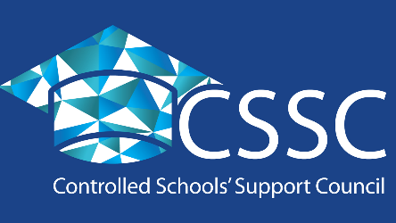

Culmore Primary School
Shared education partnership case Study

Who is your partner school and how long have you been involved in a shared education partnership with them?
There are four schools involved in the shared education partnership. Chapel Road Primary School, Oakgrove Integrated Primary School and Nursery, Ashlea Primary School and Culmore Primary School. The partnership has been running for four years.

Why did you want to become involved in a shared education partnership?
The school makes a promise to every child through the school ethos which states that:
“we will strive to respect the experiences, knowledge and cultural diversity that every child brings to school”. This programme has enabled the school to enrich the learning experiences of each child in their care by giving them the opportunity to learn alongside children from other backgrounds. It has also allowed the school to invest in the purchase of stimulating resources, allowing them to take the learning beyond the confines of the classroom.

Describe the school’s involvement in the shared education partnership and who are the members of staff involved?
- Each Teacher had an initial planning meeting via Teams to plan activities for the programme. Then continued to communicate via Teams to discuss planning and delivery, giving teachers a sense of shared responsibility and ownership.
- Each partnership school planned activities based on Literacy, PDMU, WAU/Arts/ICT/PE with each month having a different theme.
- Teachers became more upskilled in general.

All staff members were involved in this process, with the four schools planning and working together from Principals to Co-ordinators and link teachers to Classroom Assistants.

What activities does the school participate in as part of the shared education partnership?
Children took part in several online activities through the shared education partnership during the second lockdown. They completed activities through PDMU, Literacy and TWAU which helped the children to develop a greater awareness of themselves, others and the world around them. Since returning to face to face teaching the children continued with their shared education activities. They were involved in PE activities linked to the monthly themes and had the opportunity to learn about another country, sharing their findings with their partnership classes online. The children had the opportunity to meet with their partner schools via Teams which helped developed a positive approach to shared education and to their partner classes.

What has shared education brought to your school community and the wider school community in your local area?
- Shared education activities were promoted in the local press, via school websites and school social media accounts.
- Through shared education some pupils were able to form links with local businesses and join community activities for example attendance at hockey training.
- Activities where shared with parents through Class Dojo/SeeSaw/Google Classroom/Teams.
- This partnership raised the profile of shared education in the community. It has informed parents and friends of each school about shared education and how enriching it is for every pupil involved.
- It also gave the children a real sense of achievement and involvement in something much bigger than their own school alone could ever offer them. They were able to celebrate the success of the programme with their partner classes but unfortunately, due to Covid-19 restrictions at that time they were unable to hold a celebratory event for parents in person.

What advice would you give to other schools embarking or developing a shared education partnership?
To grab the opportunity with both hands. Everyone involved in the partnership will benefit from the experience, the whole school community can benefit from this and move forward in a more positive, confident way. The children will make memories and take learning experiences away from the partnerships which will help mould them for life.

Introduce the Author
Name Mrs Clare McMenamin, Principal of Culmore Primary School

